

**The European Union, monetary and financial stability, and the Bank of England**

Speech given by Mark Carney

Governor of the Bank of England

St Peter’s College, Cairncross Lecture, Oxford 21 October 2015

I would like to thank Ben Nelson and Iain de Weymarn for their assistance in preparing these remarks, and Aaron Clements-Partridge, Rashmi Harimohan, David Ronicle, Thomas Smith, James Talbot, Ryland Thomas, Nicola Anderson, Phil Evans, Richard Blows, George Murphy, Mike Flood, Peter Nagle, Nicola Shadbolt, Sinead Meany, Jumana Saleheen, Dennis Reinhardt, Bob Hills and Siobhan Clark for their work preparing *EU Membership and the Bank of England*.

# Introduction

It is a great honour to give this Cairncross Lecture in Wren’s exquisite Sheldonian Theatre.

Sir Alec Cairncross was a celebrated economist whose career bestrode public service and academia.

Born to a Lanarkshire ironmonger in 1911, he rose, via Glasgow University and Cambridge, to serve as the first head of the Government Economic Service and later, much more illustriously of course, as Master of St Peter’s College.

His work serves as a reminder of how enduring are the most trying economic questions we face.

His PhD thesis, eventually published after great anticipation in 1953, concerned British investment at home and abroad during the last great wave of globalisation – a Golden Era for global commerce that stretched from Canadian Confederation to the eve of the Great War.1

His professional preoccupations included how international capital flows, trade and labour mobility influence people’s well-being.

These factors remain uppermost in policymakers’ minds as they seek to secure the resilient dynamism we all need for sustainable prosperity. And they are among the factors I want to consider this evening in discussing the impact of the UK’s European Union (EU) membership on the Bank of England’s objectives.

Today we are publishing a report that examines this question.2

I would like to be clear at the outset what this report is about, and what it is not.

## *Our report is solely concerned with how EU membership affects the Bank’s ability to achieve our* core objectives of maintaining monetary and financial stability.

***It is not a comprehensive assessment of the pros and cons of the United Kingdom ‘being in Europe.’***

And for the benefit of those of you who join us from the ranks of the nation’s press corps, I say again that this report it is not a comprehensive assessment of the pros and cons of the United Kingdom ‘being in Europe’!

1 Cairncross, A K (1953), *Home and foreign investment 1870-1913*, Cambridge University Press.

2 Bank of England (2015), *EU Membership and the Bank of England*, October. Available [here.](http://www.bankofengland.co.uk/publications/Documents/speeches/2015/euboe211015.pdf)

Answering that question involves much, much broader issues. Issues for others to analyse, describe and debate. And even those contributions will only be partial responses to a question that only the British people can decide.

So if the narrowness of my scope disappoints, I would invite you sit back. Literally. Admire the Sheldonian’s ceiling. Marvel at how Wren’s original design bridged such an expanse with neither beams that could individually span its width nor floor-to-ceiling columns that could support it. Reflect on the allegory in the paintings that shows Truth descending upon the Arts and Sciences, expelling ignorance from the University.

While you do, I will attempt my more meagre exam question.

The Bank’s very great – yet rightly circumscribed – responsibilities are formalised in the remits of the three major policy-making bodies of the Bank – the Monetary Policy Committee (MPC), the Financial Policy Committee (FPC), and the Prudential Regulation Authority (PRA).

The MPC’s remit requires it to achieve price stability, formalised as 2% CPI inflation, and subject to that to support the Government’s economic policy including its objectives for growth and employment.

The FPC works to remove or reduce systemic risks with a view to protecting and enhancing the resilience of the UK financial system as a whole, and is subject to the same secondary objective as the MPC.

And finally, the Bank of England’s PRA is required to promote the safety and soundness of individual firms; to contribute to securing an appropriate degree of protection for insurance policyholders; and, subject to that, to facilitate effective competition.

Price and financial stability, as well as safety and soundness of banks and insurers, are essential macroeconomic pre-requisites for sustainable prosperity, but they are not sufficient for its attainment. They are the foundations not the edifice.

The Bank’s responsibilities are enshrined in statute. We pursue them under operational independence and are accountable to the people of the United Kingdom through Parliament for their achievement.

Effectively discharging our responsibilities requires a deep understanding of the forces affecting the UK economy. EU membership entails some of the most important.

There are three ways in which EU membership affects the Bank of England’s objectives:

* First, to the extent it increases economic and financial openness, EU membership reinforces the dynamism of the UK economy. A more dynamic economy is more resilient to shocks, can grow more

rapidly without generating inflationary pressure or creating risks to financial stability, and can also be associated with more effective competition.

* Second, increased economic and financial openness means the UK economy is more exposed to economic and financial shocks from overseas. As a result of closer integration within the EU and, more recently, with the euro-area crisis, this may have increased the challenges to UK economic and financial stability; and
* Third, EU regulations, directives and rules define many of the Bank of England’s policy instruments particularly in relation to financial stability. These must be sufficiently flexible and effective to manage the consequences for the United Kingdom of shocks originating at home and abroad.

All of these forces are in flux.

For the majority of the period since the UK joined the EU, the first factor – greater openness and deeper integration afforded by EU membership – very likely increased the UK’s dynamism.

To be clear, by dynamism I mean the ability of an economy to grow and progress. Dynamism is reflected in the rate of productivity growth, the degree of labour engagement, the pace of new business creation and the rate of new innovation. In the period since joining the EU, the UK has had among the fastest per capita growth rates in the G7,3 has consistently been one of the top destinations for foreign capital amongst advanced economies as well as the top destination for Foreign Direct Investment in the EU. Today, the UK economy stands as one of the most flexible not just in the EU but across the advanced world.

Since the crisis began, the second factor – shocks arising from our biggest and closest trading partner – has challenged UK dynamism and made it more volatile.

In the aftermath of the crisis, it is essential that the third factor – EU rules, directives and regulation – continues to support the UK’s ability to address risks to financial stability in the future.

# Openness, dynamism and stability

The UK is an open economy *par excellence*. In fact, the UK has bet on openness for almost two centuries. A bet that has paid off handsomely.

3 Per capita growth in the UK was fastest in the G7 1973-2008. Including the period since the crisis, the UK falls to second, after Japan.

From the repeal of the Corn Laws onwards, the UK has acknowledged that impediments to free trade are seldom, if ever, ‘first best’ responses to the many maladies from which market economies can suffer.4

Where the UK has led, others eventually followed. In time, every major advanced economy has come to embrace openness as a strategy to promote the well-being of its citizens.

Today, the UK’s trade totals around two-thirds of its GDP (**Chart 1**). Its external assets and liabilities exceed ten times GDP. And its share of global Foreign Direct Investment (FDI) is around two times its share of global activity, accounting for the largest share of FDI into the EU (**Chart 2**).

Its openness extends beyond the real economy to the financial economy.

The scale, complexity and degree of global activity of the UK financial system are unmatched in the European Union (**Chart 3**). More foreign banks operate in the UK than any other EU country, and more than half of the world’s largest financial firms have their European headquarters in the UK. The UK has the largest global share of cross-border bank lending, foreign exchange trading, and OTC interest rate derivatives. It has the world’s third largest insurance industry and its second largest asset management industry. The UK banking sector is four times GDP and non-bank financial institutions are a similar size (**Chart 4**), while financial services accounted for 8% of output and around 3½% of employment in 2012.

From this real and financial openness flow two important consequences for the UK economy and for the Bank’s objectives.

* 1. *Openness and Dynamism*

The first is dynamism.

Cross-border integration of goods, services, labour and capital markets increases an economy’s dynamism through increased specialisation, enhanced competition, and greater possibilities for diversification and

risk-sharing.

Greater openness boosts the size of markets that UK households and firms can access. In turn, trading in larger markets spurs innovation and promotes the adoption of new technologies from abroad. It also intensifies competition and drives efficiency improvements not least by allowing firms to exploit economies of scale.

4 See, for example, Lipsey, R G and Lancaster, K (1956), “The general theory of the second best”, *The Review of Economic Studies*, **24**

1.

The openness associated with the free movement of labour can help better match workers with firms, alleviating skills shortages and boosting the supply side or the potential growth rate of our economy.

And greater openness can enhance the allocation of capital by better matching lenders with borrowers, potentially financing growth-enhancing investment. Foreign Direct Investment has particular benefits. By creating stable and long-lasting links between economies, it assists economic integration and boosts dynamism by establishing channels for technology transfer and skills improvements.

The impact of openness on dynamism is not unambiguous, however. It depends on a range of factors including an economy’s factor endowments, the complementarities that exist between these and its production technologies, and the correlation of shocks between the domestic and world economies.5

Although openness supports dynamism, integration also brings greater exposure to foreign shocks.

* 1. *Openness and Stability*

Those observations point to a second important influence of openness on the UK economy: stability.

As the UK has become more open over time, its interdependence with other economies, including others in the EU, has increased.

For the macroeconomy, this has two opposing effects.

First, openness can enhance the investment returns and opportunities to diversify risks of households, firms and financial institutions.

Well-managed openness can therefore grow wealth while enhancing risk-sharing, insuring households’ consumption, smoothing their working patterns, and augmenting their borrowing and saving opportunities.

That insurance helps people plan for the future in the knowledge they’ll have to change their plans less abruptly when the unexpected happens.

The flip-side is that openness can change the nature of the unexpected itself, altering the type and scale of shocks hitting the economy.

For example, the complexity of financial linkages can grow and become more opaque, creating new vulnerabilities and more severe shocks.

5 See for example Grossman, G and Helpman, E (1991), *Innovation and growth in the global economy*, MIT Press.

And openness has the potential to exacerbate existing distortions or inefficiencies. In times of euphoria, foreign capital can flood in and amplify domestic trends. The speed of its flight when passion turns to panic can then deepen the bust that follows boom.

Most obviously, openness ties the fates of trading nations together.

That can mean a ‘second engine’ for growth from abroad. But it can also mean a dragging anchor when things go awry across borders.

# Role of the EU in UK dynamism and stability

How has the EU affected the UK’s dynamism and stability? Let me begin with the first.

* 1. *Role of EU in UK Dynamism*

In some respects the UK is the leading beneficiary of the famous ‘Four Freedoms’ first set out in the 1957 Treaty of Rome.6

These are the free movement of goods and services, capital and labour, enhanced over time through a range of measures to reduce impediments across the EU.

So although the UK’s dynamism is the product of many factors including deep human capital, well-developed physical infrastructure, a competitive fiscal regime and the rule of law; the EU has arguably bolstered it by establishing the world’s largest single market with free movement of goods, services, capital and labour.

The UK has further benefited from these dynamics by retaining relatively flexible labour and product markets.

In product markets, home and foreign firms receive close to equal treatment; the administrative burden on start-ups is second lowest in the G7; incumbent firms receive the lowest regulatory protection in the G7; and product market regulation is light (**Charts 5-8**). Partly as a result, in 2012 the UK economy created firms at more than three times the rate of the US.7

Taken together, these measures promote competition and spur innovation which ultimately benefits us all. And the UK has managed to combine some of the most flexible labour markets in the G7 with some of the most cooperative labour relations (**Charts 9-10**).

6 And now set out in the Treaty of the EU and the Treaty on the Functioning of the EU.

7 Compared using business creation rates scaled by relative GDP.

This relative labour market flexibility helps the economy to absorb shocks, illustrated by the experience of the Great Recession. UK unemployment rose by less than in the US, and has fallen faster than in the euro area. Since the start of the Global Financial Crisis, UK jobs have grown 3 percentage points more than the US.

Moreover, people’s attachment to the workplace has remained broadly intact. Compare that with the case of some euro members, where youth unemployment in particular has been devastatingly high, and with the US, where there was an unexpected rise in worker discouragement, with many working age adults exiting from the labour market altogether.8 This out-performance is positive for the UK’s dynamism in the medium run.

More to the point, that means more people in work, building not losing skills, with real prospects for higher wages and better living standards.

That is important because the UK still has work to do to close the gap between its productivity performance and the world frontier, defined by the United States (**Chart 11**). However, over the broad sweep of its EU membership, the UK’s productivity growth performance compares favourably. And its potential growth is at the top of the class of the major advanced economies.

An important driver of that dynamic has been FDI. Since the establishment of the single market in 1992, the UK has been the top recipient of foreign capital in the EU.

Evidence suggests that the openness of EU economies to foreign investment has improved firm-level productivity both through technology transfer and enhanced management practices (**Chart 12**). This has likely been complemented with labour flows leading to better-matched skills.

Broadly speaking, the evidence suggests that UK has successfully harnessed the benefits of openness afforded by its EU membership while avoiding some the drawbacks of reduced flexibility from which some continental European economies suffer.

* 1. *Role of EU in UK Stability*

If the impact of EU membership on openness and dynamism is relatively clear, its effect on stability is more complex.

Greater dynamism makes a given burden of debt easier to service, enhancing resilience to shocks. And the common rules and diversification afforded by EU membership bring the potential for financial stability benefits.

But there have also been challenges.

8 For a further discussion of these points, see: Carney, M (2014), *Speech at the Trades Union Congress Annual Conference*, September.

Greatly increased financial openness, in part associated with EU membership, has made the UK financial system larger, more complex and more exposed to shocks from abroad.

These developments reinforced domestically generated vulnerabilities in the run up to the Global Financial Crisis. The UK, along with many of its main international partners, lacked the institutions and tools for managing and addressing them when they crystallised.

As a result, when the crisis hit, global shocks were transmitted virulently across borders, doing great damage to the financial systems and real economies of many countries. The UK was particularly affected given its high degree of financial openness.

Most recently, challenges arising from European Monetary Union (EMU) have been particularly evident. Our ties are close. 40% of our exports go to the euro area, and major UK-owned banks have financial exposures to the euro area totalling almost twice their capital, worth a quarter of UK GDP.

These figures underscore the importance to the UK of further building the resilience of the euro area as part of a strengthened European Union.9 In this regard, the progress made in recent years is particularly welcome. Nonetheless, as highlighted in the European Commission’s ‘Five Presidents’ Report’, the euro area remains “unfinished business.”10

Actions to complete European Monetary Union should be taken with regard to their impact on all members of the European Union. From the Bank of England’s perspective, steps to ensure financial stability for those *within* the euro area should not impede the achievement of financial stability for those *without*, including the United Kingdom.

# Impact on the Bank of England objectives

So what does this analysis means for the achievement by the Bank of its statutory objectives? Let me begin with monetary policy.

* 1. *Monetary policy*

Put simply, economies with sustainable dynamism can grow more quickly before running into excessive price pressures. The UK’s greater openness as a result of EU membership provides potential for both greater growth and shocks.

9 For further discussion of these points, see Carney, M (2015), “Fortune favours the bold”, Speech at Iveagh House, Dublin, 28 January.

10 See Draghi, M (2015), “Stability and prosperity in monetary union”, 2 January.

The MPC naturally takes these into account when setting monetary policy for the UK. While they have posed challenges at times, the influence of EU membership on these dynamics does not prevent the MPC from achieving its price stability objective.

Under inflation targeting the MPC has ultimate control over the UK’s nominal destiny, allowing the flexibility of the exchange rate and free capital flows to facilitate adjustment to global shocks.

The precise path of that adjustment is a policy choice we are free to make, within the framework provided by our monetary policy remit.

For example, at the onset of the crisis, a large adjustment of the UK’s real exchange rate was necessary to rebalance from domestic to foreign demand, reflecting the severe headwinds to domestic growth from deleveraging by UK households.11

The consequences of this real adjustment for inflation depended on the monetary policy response. The MPC was able to strike an appropriate trade-off, consistent with its remit, between the needs to stabilise inflation and to avoid undue volatility in employment and output. Some have put this more colloquially as ‘looking through’ the effects of sterling’s depreciation on inflation on this occasion.

More persistent shocks require monetary accommodation. For example, the euro area’s difficult sequence of internal price adjustments, together with its overall fiscal restraint and tight credit conditions, imparted persistent headwinds to UK growth, and, had they not been addressed, on inflation.

Those headwinds contributed to a persistent lowering of the ‘equilibrium’ interest rate in the UK – the rate required to maintain demand in line with potential. That called for Bank Rate to be held lower for longer in order to lean against the disinflationary impulse emanating from abroad. And low real rates have had to be complemented by targeted macroprudential measures to insure against the risks of excessive indebtedness.

Both of these points illustrate that the UK’s openness is central to the deliberations of the MPC in formulating monetary policy strategy. But neither openness nor any obligation of EU membership ultimately prevents the MPC from doing its job.

* 1. *Financial stability*

The impact of EU membership on financial stability is more challenging.

11 See Broadbent, B (2011), “Rebalancing and the real exchange rate”, Speech at Thompson Reuters, London.

Given the close integration of the UK financial sector with the rest of the EU, it is imperative that the EU has a robust regulatory framework. This is in the process of being achieved.

Through its membership of the EU, the UK is promoting a strong global regulatory framework, and UK authorities have worked in close concert with our European partners to find solutions to the fault-lines of the past. Examples include moves to end Too Big To Fail by enhancing bank recovery and resolution, a solution developed locally at the Bank of England, implemented regionally in the European Union, and now agreed globally through the Financial Stability Board.

Given the scale of the UK’s financial sector relative to its economy, the Bank of England also has a special responsibility to the UK, to Europe and the world. The UK must ensure that the system is robust to shocks and that financial institutions can be resolved in an orderly manner.

After all, financial stability is a national responsibility, with the UK taxpayer serving as the ultimate backstop of the UK financial system.

The comprehensive reform of the UK’s institutional framework for financial stability since the crisis creates a coherent architecture of national macroprudential and microprudential regulators and supervisors. This is now commensurate with the scale and nature of the risks that the UK’s high degree of financial openness can pose. And it provides the foundations for the UK to remain the world’s leading international financial centre, one which can safely be home to the largest global, systemically important banks and insurers.

The effectiveness of our reformed domestic framework for financial stability depends in part on the quality of financial regulation set at the EU level as well as the flexibility we have to apply that regulation to meet the UK’s specific financial stability challenges. In the main this combination has been achieved thus far.

However, there have been some limits on flexibility in certain areas, including:

* a bonus cap restricting the proportion of pay that can be clawed back in the event of excessive risk taking or poor conduct, thereby weakening discipline from remuneration;
* trigger thresholds for contingent convertible capital instruments that some may judge too low; and
* a reduced role for national discretion in insurance supervision.

While common international standards and effective EU rules should continue to support the operation of the single market, it is imperative that UK authorities, including the Bank of England, continue to retain the flexibility to impose the high standards necessary to manage the world’s leading global financial centre.

This flexibility may be challenged by how EU financial regulation evolves. Ensuring the Bank of England has the instruments necessary to achieve its financial stability objective will depend on the EU continuing to have regulations of the highest standards, which strike the appropriate balance between harmonisation and flexibility, and which accommodate necessary national responsibilities, including for supervision.

# Principles of a new settlement for financial stability

A successful and sustainable Economic and Monetary Union is important for the dynamism and stability of both the euro area and the UK. Since the crisis, many euro-area economies have undergone difficult reforms to improve competitiveness. Adjustment mechanisms to address the underlying problems of the euro area have been built, including measures to create a Banking Union and the development of the European Stability Mechanism, a permanent crisis resolution facility for euro area countries.

Although much has been accomplished, further financial and fiscal integration within the euro area will be necessary to put EMU on a more sustainable basis. In particular, closer financial integration requires increased risk sharing in the public and private sector. That risk sharing can be achieved by the development of the more complete Banking Union in the euro area and, more broadly, a Capital Markets Union for the EU.

How financial regulation in the EU evolves in future will be critical to the resilience of both the euro area and the UK economy. Closer union between euro-area member states is likely to necessitate further harmonisation of financial regulation across the euro area. By extension, those regulations can affect the rest of the EU.

In that light, it is important that any future EU legislative measures, designed to meet the needs of deeper integration in the euro area, do not adversely affect the Bank of England’s ability to ensure the stability of the UK financial sector or compromise the single market.

It is desirable, particularly given the weight of the ECB and of the members of the single currency within the EU, that there are clear principles to safeguard the interests of non-euro member states.

The future direction of EU financial reform should recognise that the EU comprises multiple currencies with multiple risks.

Such principles would enable the Bank of England to continue to ensure that EU membership contributes fully to the attainment of the Bank’s statutory objectives.

***

Overall, EU membership has increased the openness of the UK economy, facilitating dynamism but also creating some monetary and financial stability challenges for the Bank of England to manage. Thus far, we have been able to meet these challenges.

Our efforts have been helped by the strong domestic framework for financial stability that has been put in place post crisis. Going forward, these should be further buttressed by an evolution of the EU regulatory framework that continues to work for all members of the EU.

The increased resilience that brings is a necessary condition for dynamism. And a dynamic, resilient domestic economy will enhance the prosperity of the people of the UK and beyond.

And for those still looking upwards in wonderment? The genius of Wren’s ceiling was its inspired interlocking beams, individually insufficient to span the Sheldonian’s diameter, but collectively arranged so that each could support another, perfectly balancing the forces of those pushing down with others pushing up, resting, ultimately, on the foundations Wren began in 1664.

And this is the architecture of Europe: a single market whose participants are interlinked, relying on and complementing each other. Just as Wren’s wooden lattice supports Robert Streater’s art, this market network supports the creativity of Europe. Of course, the weight of the ceiling doesn’t disappear but rests on hidden foundations. So too does the single market rely on invisible supports, some of which are the responsibility of the Bank of England and European regulatory authorities. While these foundations have worked well thus far, they may in time need to be buttressed to realise the full creative potential of the peoples of the United Kingdom and Europe.

# Chart 1Chart 1\\govs\Files\Bookend\Charts for Bookend Report\Charts for Publication\Set charts\Chart 1.13 international.pngChart 1CHARTS

|  |  |
| --- | --- |
| **Chart 1: UK trade is two-thirds of GDP** | **Chart 2: UK receives largest share of EU FDI(a)** |
| Source: OECD | (a) EU-15 countries’ share of average annual FDI inflows into the EU: 1993 to latest.  Source: UNCTAD. |

|  |  |
| --- | --- |
| **Chart 3: Global activity of UK financial system unmatched in the European Union…** | **Chart 4: … and UK financial system is very large relative to GDP(a)** |
| Notes: Bars show share of global activity for cross-border lending, interest rate OTC derivatives and foreign exchange and share of global assets for all other categories.  Cross-border bank lending and mutual fund asset data are from 2014; all other data is from 2013.  Source: BIS, City UK, IMF’s GFSR, Bank calculations. | (a) Excluding derivatives. The ‘Financial system’ is defined as total assets of the financial corporations sector (excluding derivatives), measured on an unconsolidated basis. For 1958 and 1978, the total assets of the individual subsectors covered in the Radcliffe and Wilson Reports are summed to give an illustrative total for the financial system. Due to availability, data for Switzerland are from 2012.  Source: Radcliffe Report (1959), Wilson Report (1980), ECB, OECD, Swiss National Bank and Bank calculations. |

|  |  |
| --- | --- |
| **Chart 5: Foreign suppliers receive close to equal treatment to domestic firms in the UK(a)** | **Chart 6: UK administrative burden on start- ups second lowest in G7(a)** |
| (a) US data relate to 2008, all others 2013. The index is a composite indicator of differential treatment for foreign firms with respect to taxes, subsidies, public procurement, entry regulation and appeal and procedures.  Source: OECD (2013), Product Market Regulation Database. | (a) US data relate to 2008, all others 2013. The measure is a composite indicator of the regulatory burden for establishing new firms or entering the service sector.  Source: OECD (2013), Product Market Regulation Database. |

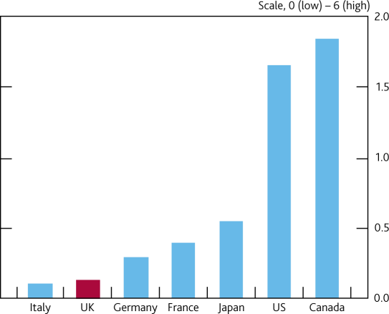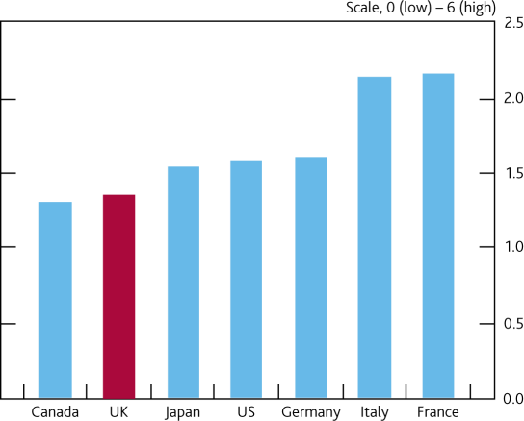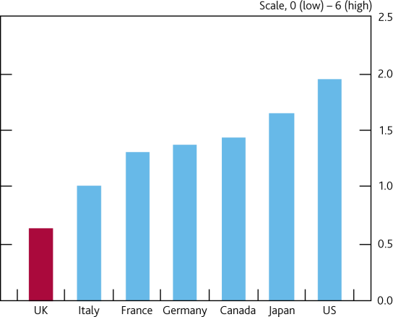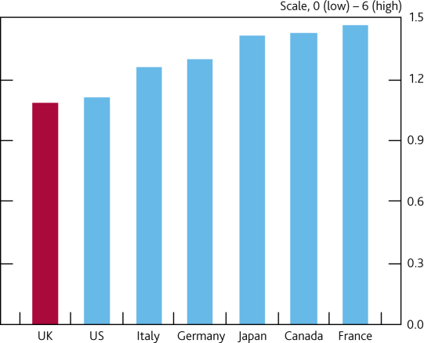

|  |  |
| --- | --- |
| **Chart 7: Incumbent firms least protected in UK(a)** | **Chart 8: UK product market least heavily regulated in G7(a)** |
| (a) US data relate to 2008, all others 2013. The measure is an indicator of exemptions from competition policy and barriers to entry.  Source: OECD (2013), Product Market Regulation Database. | (a) A summary measure of product market regulation, which aims to capture the degree of protection in product markets. A high score would be associated with policies being in place that could stifle competition and innovation. The measure is an indicator based on scores across 18 lower-level categories. US data relate to 2008, all others 2013.  Source: OECD (2013), Product Market Regulation Database. |

|  |  |
| --- | --- |
| **Chart 9: UK employment protection in middle of the G7 pack(a)…** | **Chart 10: … while securing favourable labour- employer relations compared to Japan and**  **Germany(a)** |
|  |  |
| (a) UK data relate to 2014, all others 2013. Measure based on indicators of the stringency of regulation, case law and collective bargaining concerning individual and collective dismissal.  Source: OECD Employment Protection Legislation. | (a) Indicator based on responses to the following question in the WEF Executive Opinion Survey: “In your country, how would you characterize labour-employer relations? (1 = generally confrontational; 7 = generally cooperative)”.  Source: WEF Global Competitiveness Report 2014. |

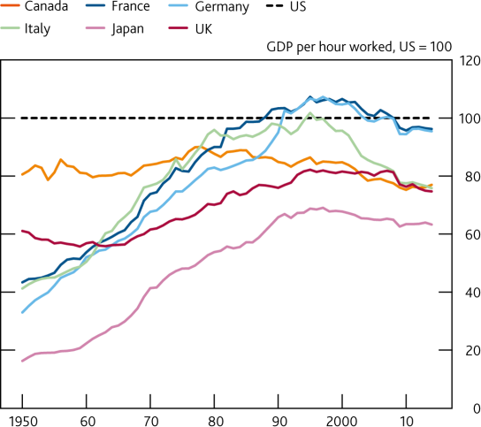

|  |  |
| --- | --- |
| **Chart 11: UK still has work to do to close the gap between its productivity level and world**  **frontier, but growth since 1970 compares favourably(a)** | **Chart 12: Firms report FDI as a channel for technology transfer, particularly in the UK(a)** |
|  |  |
| (a) Output per hour measured in 2014 US$, with price levels converted using 2011 PPPs.  Source: The Conference Board Total Economy Database. | (a) Indicator based on responses to the following question in the World Economic Forum Executive Opinion Survey: “To what extent does FDI bring new technology into your country? (1 = not at all; 7 = to a great extent—FDI is a key source of new technology)”.  Source: WEF Global Competitiveness Report 2014. |